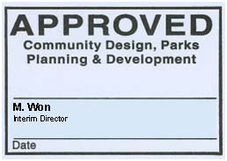

Insert Application Title Here
Design Brief
Insert Design Brief Type (Institutional/Commercial, etc.) Here

Street Address, Brampton, Ontario

Insert Conceptual Image(s) of Proposed Development Here

Prepared by:
XYZ Limited, Landscape Architecture
ABC Limited, Architects

Prepared for:
123 Developments Ltd.

OR Insert company logos.

Submitted to the City of Brampton
Submission Number: 1st Submission, 2nd Submission, etc.
Date: DD/MM/YYYY
City File Number: X00X00.000
Subdivision File Number: 21T-00000B

